MotherCoders is a non-profit organization whose mission is to help women with kids on-ramp to careers in tech so they can thrive in a digital economy. As part of a campaign to help moms break into tech, they are using an unweighted tree to reach new mothers at companies joining work after maternity leave. The goal is to visit all mothers who are joining back after maternity leave across a company hierarchy by traversing a tree (organization) through its nodes (employees), and find the most optimal way to do so.

More formally, given an unrooted unweighted tree of n nodes, it is needed to travel from node 1 to node n by following a path. It is compulsory to visit a set of nodes visitNodes in the path followed.

Thus, the path must follow the given conditions:

* The path starts at node 1.
* *The path*ends at node n.
* The path can visit each node any number of times.
* Each node in visitNodes must be visited at least once in the path.
* From a current node, it is possible to travel to an adjacent node.

Among all such paths, find the minimum length path and return the length of this path.

Given an unrooted unweighted tree of n nodes, and an array visitNodes[] of length m, find the minimum length of the path from node 1 to node n such that it visits all the nodes among visitNodes (in any order) at least once.

Note: All the elements in visitNodes are unique.

Example:

Let’s suppose the given tree is as follows:

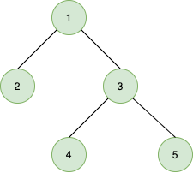

The set of nodes you must visit in the path, visitNodes = [2, 4].

So, to visit from node 1 to node 5, you can travel in the following pattern:

1 → 2 → 1 → 3 → 4 → 3 → 5

This is the minimum length path, hence the answer is 6.

Function Description

Complete the function findMinimumPathLength in the editor below.

findMinimumPathLength has the following parameters:

    int n: an integer

int edges[n][2]: a 2d array of integers

    int visitNodes[m]: an array of integers

Returns:

int: an integer denoting the minimum length path

Constraints

* 1 ≤ n ≤  2 · 105
* 1 ≤ edges[i][0], edges[i][1] ≤ n
* 0 ≤ m ≤ max(0, n – 2)
* *2*≤ visitNodes[i] ≤ n – 1

Input Format For Custom Testing

The first line contains an integer, n, denoting the number of nodes in the tree.

The second line contains an integer, n – 1, denoting the number of elements in array edges.

The third line contains an integer, 2, denoting the number of columns in array edges.

*The next*n-1 lines contain two integers each, edge[i][0] and edge[i][1].

The next line contains an integer, m, denoting the number of elements in array visitNodes.

The next m lines contain one integer each, visitNodes[i].

Sample Case 0

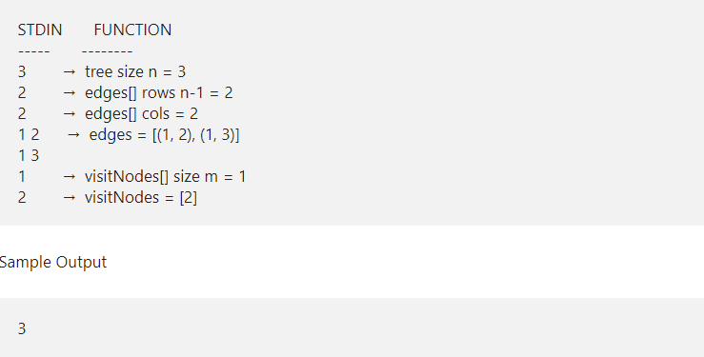

Explanation

The given tree is as follows:

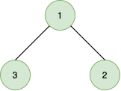

The path that needs to be followed is:

1 → 2 → 1 →3

Therefore, the answer is 3.

Sample Case 1

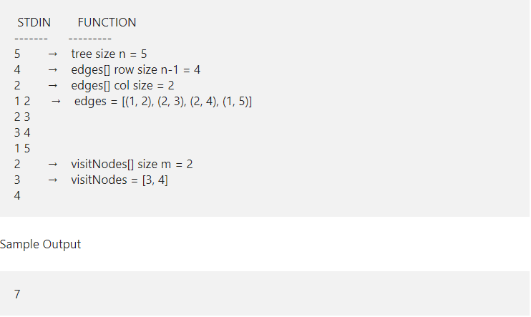

Explanation

The given tree is as follows:

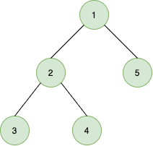

The path that needs to be followed is:

1 → 2 → 3 → 2 → 4 → 2 → 1 → 5

Therefore, the answer is 7.